**Analysis**

Problem:

My project is an application that enables companies to rent a means of vehicles to customers. The administrator of the company will be operating the application and will therefore have their own login. The administrator will have privileges such as adding, removing, updating and searching items in the database. They will be able to do this to vehicles and customers.

The challenge in this project will be to provide a suitable and easy interface for the administrator to use. To do this, I will have to limit the number of buttons I create to avoid difficulties for the user and provide simplicity.

Stakeholders:

The end users that this program is aimed at are administrators of a company or staff with IT skills. For this project I have chosen two students from my computer science class, Ben Howard and Abdul Mustapha who I will be able to question regularly. I have chosen students who take computer science to get technical feedback. They will need a laptop/computer that does not need access to the internet and a username and login. (Which they already have because the college provides it for them) The stakeholders are in the age range of 17-18 and have sufficient computing ability as they both take computer science.

I have interviewed my stakeholders Abdul and Ben and asked them what you would normally require when using a piece of software. They needed a login, access to all databases and the ability to send and keep a record of invoices to deal with any inquiries.

Computational Methods:

Thinking Procedurally and Decomposition

Breaking down the program into smaller detail helps thinking ahead and figuring out the order of which part of the program needs to be created first.

I have broken down the problem into 4 main sections:

1. Log-In: The administrator will have access to every part of the program except, if the person logging in is (for example) a sales employee, they will be restricted to certain aspects of the program such as editing which vehicles are present in the database and deleting customers from the database as they will be mainly interested in hiring the vehicle to the customer. This means I will have to make changes to my program such as hiding buttons and certain functions depending on who logs in.
2. Customer Database: The administrator and other staff will be able to access this part of the program to add, delete, search and update a customer’s details. I have made it easy to view the information from the databases by using data-grid-views.
3. Vehicle Database: Only the administrator will have access to this part of the program and will be able to add, delete, search and update a vehicle’s details. I have also used a data-grid-view for this part to make it easier to visualise the data.
4. Hiring a vehicle: A vehicle salesman would typically use this part of the program to hire a customer to a vehicle. In this part of the program you can calculate the total amount that the customer needs to pay and generate an invoice to confirm the details which can be emailed and printed.



Thinking Logically

To check whether the user has entered their log-in details correctly, I would have to program the function in a way where it loops through each existing user and checks if the details are exactly the same.

Thinking Ahead

To login, access vehicles and customers, the program will need to access different databases. Therefore, these databases need to be linked to the program and working. However, in an instance where the databases cannot be accessed, a method will need to be implemented that will prevent the program from crashing. Additionally, the databases will be made using Microsoft Excel, so the computer running the program will need to have Microsoft Excel installed.

Inputs

The list below is made up of functions that are required for the program to work successfully.

Main Menu:

* Login

1. The user will be able to enter their username and password into two text boxes.
2. The user will be able to click a button that will check if their login details are correct.

* Customer Database

1. The user will be able to click a button to add a customer record into the database.
2. The user will be able to click a button to remove a customer record from the database.
3. The user will be able to click a button to update a customer’s record from the database.
4. The user will be able to click a button to search an existing customer’s record from the database.

* Vehicles Database

1. The user will be able to click a button to add a vehicle’s record into the database.
2. The user will be able to click a button to remove a vehicles record from the database.
3. The user will be able to click a button to update a vehicle’s record from the database.
4. The user will be able to click a button to search an existing vehicle’s record from the database.

* Hiring vehicles

1. The user will be able to click a button which will allow them to search for a customer and vehicle in the databases.
2. The user will be able to tick an option for insurance.
3. The user will be able to click a button which calculates the total amount needed to pay.
4. The user will be able to click on a button which will generate an invoice.

* Button that allows the user to exit the program.

Outputs

* Login

1. When the user attempts to login, they will be told if they have successfully logged in and if they do, they will be taken to the main menu where they will have access to all the databases depending on whether they are staff or an admin.

* Customer Database

1. When the user clicks on the add button after entering the details in the textboxes, the details will be sent to the text file.
2. When the user clicks on the delete button after selecting the details in the data-grid-view, the details will be removed from the text file.
3. When the user clicks on the update button after changing the details in the textboxes, the details will be changed in the text file.

* Vehicle Database

1. When the user clicks on the add button after entering the details in the textboxes, the details will be sent to the text file.
2. When the user clicks on the delete button after selecting the details in the data-grid-view, the details will be removed from the text file.
3. When the user clicks on the update button after changing the details in the textboxes, the details will be changed in the text file.

* Hire a vehicle

1. If the vehicle/customer searched in the database is found, then a message will be displayed, and the vehicle/customer will be highlighted in the data-grid-view.
2. If the user selects a row from the data-grid-view, the data will be transferred into textboxes.
3. When the calculate button is clicked, the program will calculate the final price including a fixed VAT of 25%.
4. When the invoice button is clicked, the user will be directed a new page with a generated invoice. From there, they will have the option to print and email the invoice.

Conclusion

The three previous examples have shown that there are features in my program that can be solved using computational methods, making it suitable for a computer program. By using these three methods, my program now has a certain structure where my functions are in a well-placed order and should therefore not be difficult to use.

Research

I have found a successful company that uses a similar concept as my program.

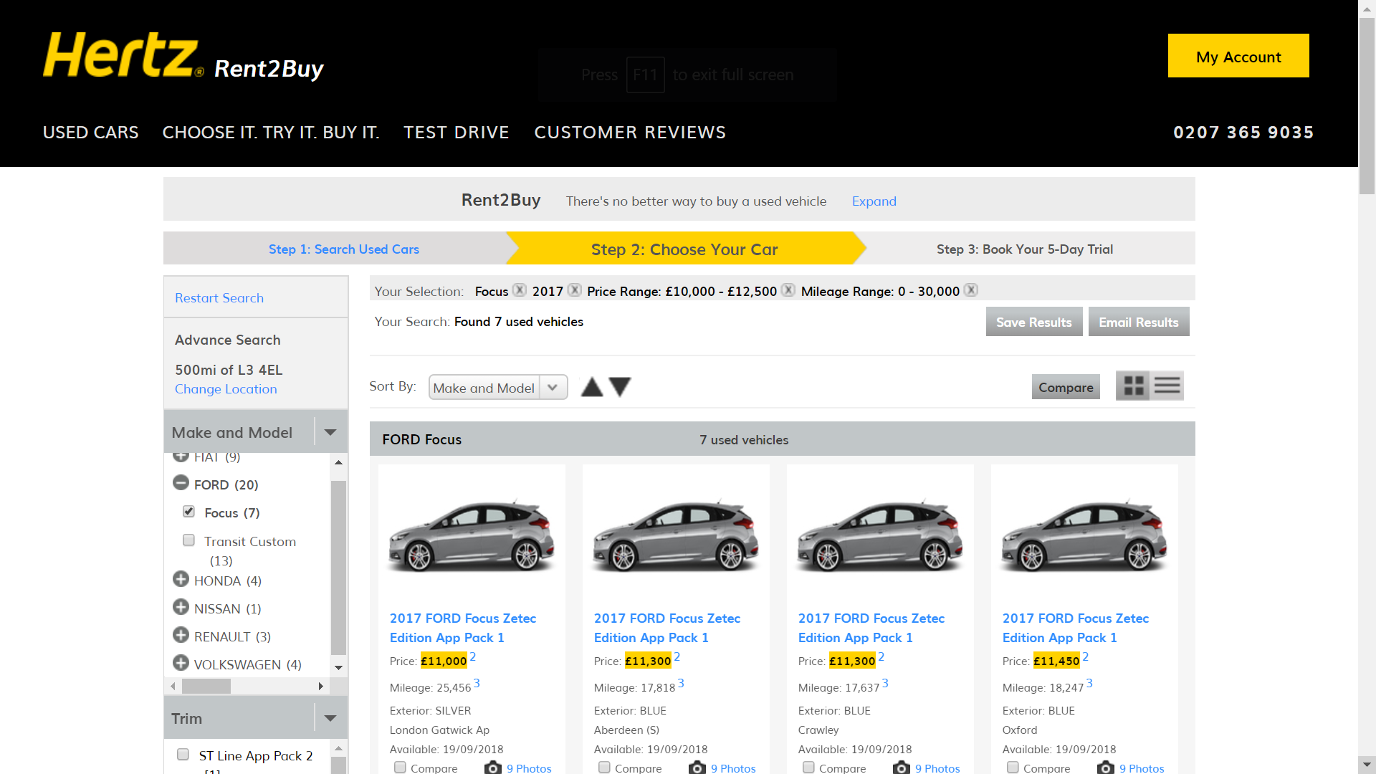

The company Hertz has a website that allows users to create their own account which allows them to hire any type of vehicle they want, ranging from economy to exotic. The company gives the user the option to set-up their account on the internet or if they find it too complicated, they can visit one of the company’s branches and an employee would be able to set-up your account for you and hire a vehicle for you. I would not be able to offer the customer an option to set-up their account on the internet as it is too time consuming.

A feature that I saw on their website which I could add to my program is the number of doors a vehicle has, it’s colour and whether it uses diesel or petrol. I could also use this website’s prices and compare it to my prices to see whether they are suitable enough to compete in this competitive market.

Interview with Abdul Mustapha to get an idea of the basic requirements

Interview: 13/09/2018 Planning

The following are a series of questions which are essential for my program in order to provide the best usability:

1. Do you need a login?
2. Do you like the design of the program?
3. Do you like the placements of the buttons and textboxes?
4. Do you like looking at data records through data-grid-views or do you prefer another way?
5. What ways would you like to edit the databases?
6. What details would you like to know about a vehicle when renting it?

Interview Script: 13/09/2018

1. Should there be more than one kind of account type?

Yes, because I wouldn’t want my details being seen by anyone.

1. Do you like the design of the program?

It’s a boring design but simple to use, so it’s fine.

1. Do you like the placements of the buttons and textboxes?

The placements of the of the buttons and textboxes are fine except for the “Hire a Vehicle” section because it is in a crowded position and so the user could press a wrong button.

1. Do you like looking at the data records through data-grid-views or do you prefer another way?

The data-grid-views were nice to use because the information was shown clearly.

1. What ways would you like to edit the databases?

I would like to add, delete and update data records. Searching for the data records would also be a good idea as it would not want to search for every record.

1. What details would you like to know about a vehicle when renting it?

I would like to know its price per day, it’s colour and whether the vehicle uses petrol or diesel.

Review of the Interview: 13/09/2018

The purpose of this interview was to see which parts of my program must be changed for a better experience and which features are essential for my program.

Login: I will have to create two types of login, in which the admin can have access to everything and other staff will be restricted to some functions.

Design: The design will have to change as the stakeholder had a request with a form.

Placements: I will have to change the button position to a more suitable and suitable position to make the stakeholder happy. Textboxes will not change positions.

Databases: I will have to program buttons which will enable the stakeholder to edit the databases the way they wanted to. I will also have to add additional information on the vehicle’s database to ensure that I do not miss out on any important information and make the stakeholder happy.

Limitations

The main limitation in this project is that I am under fixed deadlines meaning I have a limited amount of time during the development of this program. Due to this limitation, I may have to remove specific functions to compensate for this. This may lead to a reduction in the quality of my program and therefore my overall grade.

During the development of this project, I will be coding using visual basic which is a programming language which is by default supported by windows operating systems. This could be a problem if my stakeholder does not have a laptop/computer which has a windows operating system installed (windows 7 or later). This will be even more problematic because if I try to make the program adapt to a MacOS, this will cost me more of my time which I do not have much of.

With my current experience with visual basic, the overall complexity of this project should not be too difficult to grasp, although there could be some obstacles in the way such as creating two different login types or any other features that I choose to amend later on. Therefore, I will have to spend time on research to code any parts that I find difficult. This will affect the overall quality of the program and the overall time I spend coding.

Hardware Requirements

|  |  |
| --- | --- |
| Hardware | Justification |
| Monitor | To display the visuals of the program back to the user |
| Mouse | To allow the users to interact with the program they need to be able to click |
| 1GB RAM | Computers nowadays hold at least 2GB of RAM, therefore problems should not arise |
| 50MHz Processor | Powerful processors nowadays are very cheap and are therefore easily accessible |
| 1GB Storage | The program will not take up much space and the customer/vehicle details will not take up a lot of space |

Software Requirements

|  |  |
| --- | --- |
| **Software** | **Justification** |
| Windows 7 or later | The computer needs a software to be run to allow the user to interact with the computer |
| Microsoft Excel | The computer needs this to store the vehicle/customer records |

Success Criteria

|  |  |  |  |
| --- | --- | --- | --- |
|  |  |  |  |
|  |  |  |  |
|  |  |  |  |
|  |  |  |  |
|  |  |  |  |
|  |  |  |  |